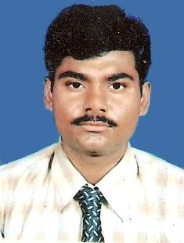
DIPANKAR GOSWAMI

Career Object
- Objective is to contribute to the level best for the development of the company.
- Surely like to contribute up to the bottom line of the company.

Personal Detail

- Father’s Name : Mr. Pran Dulal Goswami
- Address for Correspondence : 257,Sri Krishna Pally, Boral Kolkata-700154.
- Phone No. : 9836617568(M).
- Date of Birth : 12th September, 1986
- E-mail Address : dipankargoswami12@gmail.com

Education

Master Degree in Business Administration (MBA) in Marketing (Major)
And Finance (Minor) from Future Institute of Engineering and Management (FIEM) 2008-10
YGPA – 7.25

Heramba Chandra College, Kolkata 2007
Under C.U.
B.Com (Hons.)
% of marks – 60.6%, Div - I

Bhagabati Devi Memorial Institute, Kolkata 2004
Class - XII ( C.B.S.E.)
% of marks – 65.5%, Div - I

Bhagabati Devi Memorial Institute, Kolkata 2002
Class - X (C.B.S.E.)
% of marks – 59.2%, Div – Il

Project :

Summer Project Done From DLINK from 09-06-09 to 31-07-09.
My project mainly based on the study of different Networking Brands in the market, also their sales promotion technique, Data collection, and D-Link Brand competitiveness with them.

Work Experience:

SARADHA GROUP OF COMPANIES Marketing Executive in Saradha Construction Co. Pvt. Ltd., from 21st June 2010 to 30st September 2012 .

VIBGYOR GROUP OF COMPANIES
Working as a sales and marketing executive in Vibgyor Housing Ltd., from 8th October 2012 till date.

Hobby

Playing PC Games, Playing Cricket, Listening Music.

Computer Knowledge

- DIIM (Diploma in IT Infrastructure Management) from CMC Limited.

Course Details

SEM I | SEM II | SEM III
Basic Electrical and Electronics  Core Hardware  Core Operating System Technologies | Network Administration  Linux, Windows NT and Windows 2000 | Cisco Network Administration  IT Security Project
Graded Obtained : A

- MS Office – MS Word, MS Excel, MS Power Point
- Entrepreneur Resource Planning (ERP)

Languages known

- English, Bengali, Hindi.

I hereby declare that the information furnished above is true to the best of my knowledge.

_______________________
Dated: (DIPANKAR GOSWAMI)
Place:

